

# University College of Northern Denmark

## Technology and Business

## AP Graduate in Computer Science dmaj0914

# Persistence Workshop

## Database creation, Database manipulation

Authors: Supervisors:

Blagovest Bozhinov Kis Boisen Hansen  
Georgi Karavasilev Gianna Belle  
Denis Nikolov  
Ivan Manev  
Mihail Tsanov

|  |
| --- |
| Abstract |
| The purpose of this workshop is to develop user friendly software capable of handling database that contains product information, customer information and supplier information, the software must also handle sales of products. The software also includes user friendly GUI. |

Table of Contents

I. Introduction 3

II. Analysis 3

III. Mock-up 4

IV. Domain Model 5

V. Fully Dressed Use-Cases 6

VI. System sequence diagram 7

VII. Operation contracts: 8

VIII. Interaction Diagram 9

IX. Transformation. Domain model to Relational Model 10

X. SQL Scripts for Creation 11

XI. SQL Scripts for Insertion 12

# I. Introduction

Group-based problem solving is the standart teaching style in Denmark. Throughout the semester there are workshops, their purpose is to strengthen this standart. The goal of this exact workshop is to develop and learn how to use databases. The software mus have MVC (Model, View, Control Layers), also in this workshop there is a fourth layer called DB Layer that serves the purpose of storing information about the database and its variables.

# II. Analysis

During the development of this software, the layout and the GUI were discussed and edited based off a now four layer architecture, consisting of Model Layer, View Layer, Control Layer and Database Layer. While developing the software, we’ve put a lot of consideration about the end-user, we’ve also tought about how to make the GUI as simple as possible so the end-user is not confused.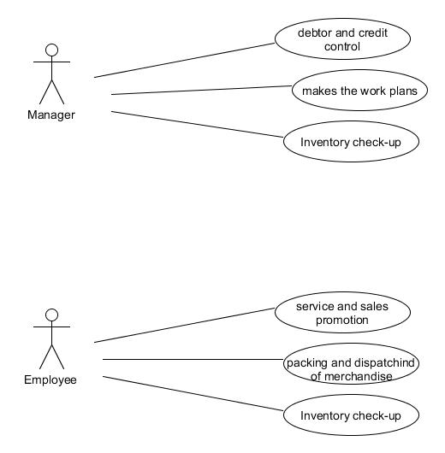

Figure 1. Use-Cases for Western Style

# III. Mock-up

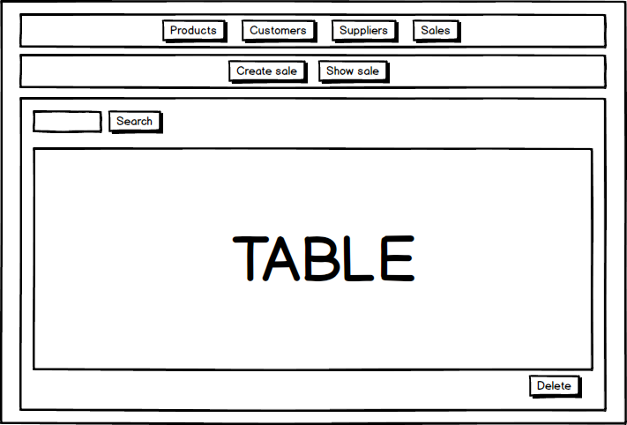

After discussion, we’ve decided to make the GUI as simple as possible and as user-friendly as it can be, with all functionality that the software is required to have. As we can see, on the first layer of buttons we have four different buttons that serve different purpose, namely Products, Customers, Suppliers and Sales. When clicked on them, another layer of buttons are shown Show and Create, which by the name ,I t can be judged that the Create button opens a table that you can create a new entry for either product, customer, supplier or a sale. When clicked on Show, we get a list of all products, customers, suppliers and sales made. The software also has a Search field and a Delete button.

# 

# IV. Domain Model

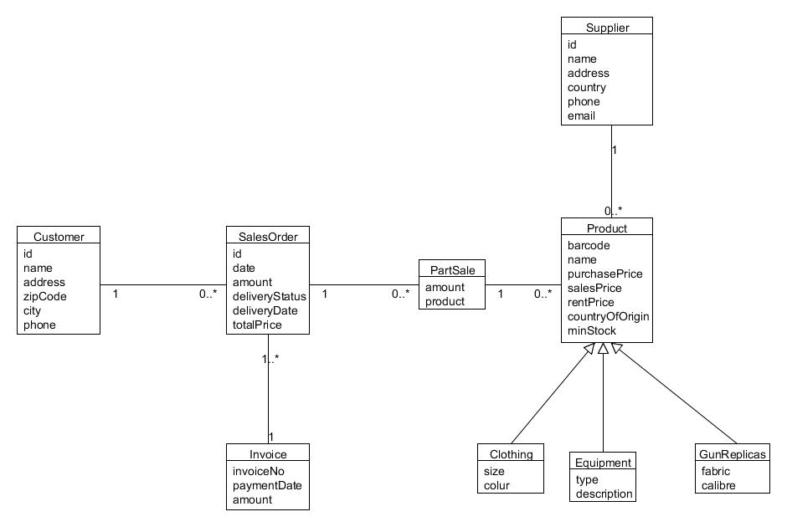

In our domain model we have class Customer with variables **id**, **name**, **address**, **zipCode**, **city** and **phone**. The **Customer** class is connected with **SalesOrder** with one to many connection. In the **SalesOrder** we have **id**, **date**, **amount**, **deliveryStatus**, **deliveryDate** and **totalPrice**, also the **SalesOrder** class is connected with the **Invoice** class which have variables **invoiceNo**, **paymentDate**, and **amount**. The **salesOrder** is also related with the **parthSale** class and the **contractor** class. The **product** has **barcode**, **name**, **purchasePrice**, **salesPrice**, **rentPrice**, **countryOfOrigin**, **minStock** fields. The **Lease** class has the **data**, **productID**, **productBarcode**, **productAmount**, **period**, **employeeID**, **customerID** fields, and the **Product** class is connected with the **supplier** class, which supplier class has fields that are **id**, **name**, **address**, **country**, **phone** and **email**.

# V. Fully Dressed Use-Cases

Use case: Product is sold

Fully dressed use case

|  |  |  |
| --- | --- | --- |
| Use case name | Product is sold | |
| Actors | Employee and Customer | |
| Pre-conditions | Product is in stock | |
| Post-conditions | Product is sold and is not anymore in stock | |
| Frequency | Every time it needs | |
| Main Success Scenario (Flow of events) | **Actor(Action)** | **System(Response)** |
| 1.Customer chooses a product and a quantity of it | - |
| 2.Employee types product’s barcode | 3.System finds the product |
| 4.Employee types the amount customer wants to buy | 5.System checks if the typed amount is available |
| 6.Employee types the customer id | 7.System finds customer and calculates total price |
|  | 8. The system get the current date automatically |
| 9.Employee finishes the sale | 10.System reports that the sale is created |
| Alternative flows | 2a. Employee types invalid barcode  3a. The system returns no products  6a. Employee types invalid customer’s id  11a System reports that a sale is not created | |

Fully dressed table about the product is sold. The main actors here are employees and customer. Pre-conditions are when the products are in stock .Post-conditions are when every time it needs.

# VI. System sequence diagram

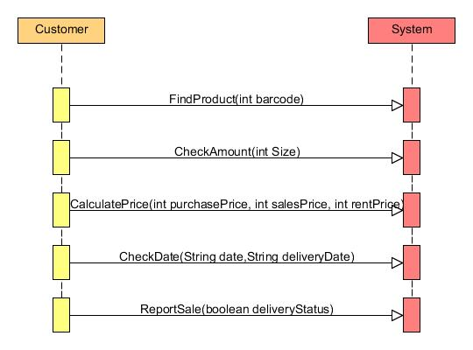

System sequence diagram about the product is sold. The main actors here are employees and customer. And the main methods are FindProduct, CheckAmount, CalculatePrice, CheckDate and ReportSale.

# VII. Operation contracts:

|  |
| --- |
| Operation: FindProduct  Use case: Product is sold  Pre-condition: Product is in stock  Post-condition:  Product is found by the system  Product is sold and is not anymore in stock |

|  |
| --- |
| Operation: CheckAmount  Use case: Product is sold  Pre-condition: Product is in stock  Post-condition:  Amount is check by the system if it is available or not  Product is sold and is not anymore in stock |

|  |
| --- |
| Operation: CalculatePrice  Use case: Product is sold  Pre-condition: Product is in stock  Post-condition:  Product is found by the system  Total price is calculated  Product is sold and is not anymore in stock |

|  |
| --- |
| Operation: CheckDate  Use case: Product is sold  Pre-condition: Product is in stock  Post-condition:  Date is checked by the system is it valid or not  Product is sold and is not anymore in stock |

|  |
| --- |
| Operation: ReportSale  Use case: Product is sold  Pre-condition: Product is in stock  Post-condition:  Product is reported by the system that it crated sale  Product is sold and is not anymore in stock |

Operation contract about the product is sold. The are four main operation which are FindProduct, CheckAmount, CalulatePrice, CheckDate and ReportSale.

# VIII. Interaction Diagram

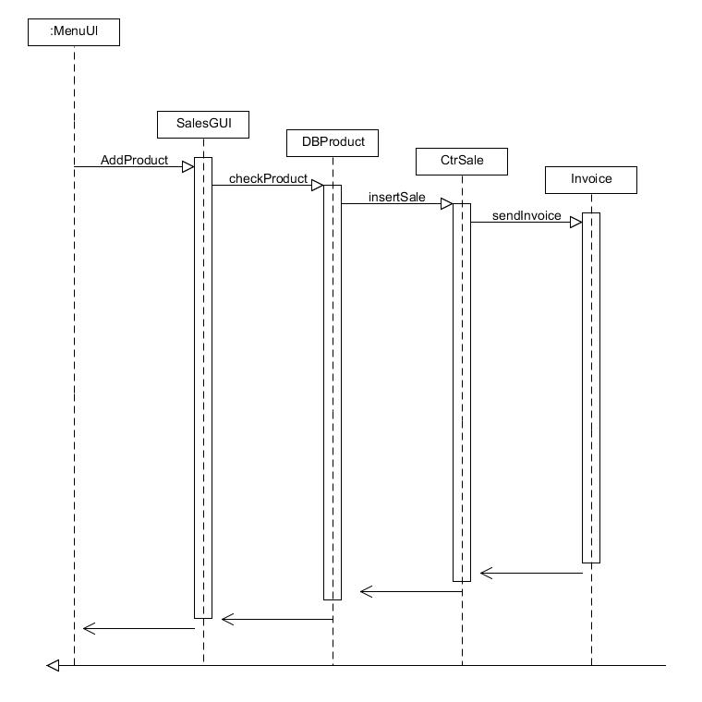

Interaction diagrams used to to visualize the interactive behavior of the system. Now visualizing interaction is a difficult task. Solution is to use different types of models to capture the different aspects of the interaction. In this interation diagram we have show our sale. First we go to our menuUl and we are adding a product then Sales class checks the product in the DBproduct class , we are insering sale from the CtrSale we are seding invoice and then everying is done.

# IX. Transformation. Domain model to Relational Model

**Customer**

|  |  |  |  |  |  |
| --- | --- | --- | --- | --- | --- |
| Id | Name | Address | Zipcode | City | Phone |
| 1 | Jhon | Lulin 8 | 1000 | Sofia | 0878110930 |
| 2 | Sara | Mladost 1 | 1000 | Sofia | 0873264591 |

We have the following fields for the customers. ID that is a primary key and int, Name and Adress that are varchar, Zipcode that is int, also we have City and Phone that are varchar.

**Sale**

|  |  |  |  |
| --- | --- | --- | --- |
| Id | Date | customerId | totalPrice |
| 1 | 02.03.2015 | 2 | 150.00 |
| 2 | 03.15.2015 | 1 | 1000.0 |

In this table we have ID that is again a primary key, Date that is type date, customerID that is int, and totalPrice which is double.

**Invoice**

|  |  |  |
| --- | --- | --- |
| saleId | saleDate | invoiceNo |
| 2 | 02.12.2015 | 15 |
| 1 | 03.13.2015 | 16 |

In the Invoice table we have the following fields. saleID that is int, saleDate is type date as in Sale, invoiceNo is type int.

**parthSale**

|  |  |  |
| --- | --- | --- |
| saleId | productBarcode | Amount |
| 1 | 15215 | 2 |
| 2 | 15216 | 20 |

Many to many relation between Sale and Product, with fields that are saleID that is from type int, productBarcode from type int and Amout that is from type int

**Product**

|  |  |  |  |  |  |  |  |  |  |
| --- | --- | --- | --- | --- | --- | --- | --- | --- | --- |
| Barcode | Name | purchasePrice | Sale Price | rent Price | countryOfOrigin | min Stock | size | supplierId | Colour |
| 15215 | Hat | 10 | 20 | 5 | Bulgaria | 10 | 5 | 2 | Red |
| 15216 | Mask | 5 | 15 | 10 | Bulgaria | 20 | 10 | 1 | Blue |

In Product we have the following fields, Barcode that is from type int, Name that is varchar, purchasePrice, salePrice,rentPrice are from type int, countryOfOrigin is varchar, minStock size and supplierId are int, color is varchar.

**Supplier**

|  |  |  |  |  |  |
| --- | --- | --- | --- | --- | --- |
| Id | Name | Address | Country | Phoneno | email |
| 1 | JumboStore | Luluin 8 | Bulgaria | 088152612 | [jumbo@abv.bg](mailto:jumbo@abv.bg) |
| 2 | FunZone | Mladost | Bulgaria | 084651354 | funzone@abv.bg |

In this table we have ID that is primary key and int, Name,Adress and Country are varchar , Phoneno and email are varchar.

# X. SQL Scripts for Creation

CREATE TABLE Customer(

id int NOT NULL,

name varchar(50) NOT NULL,

address varchar(50) NOT NULL,

zipcode int NOT NULL,

city varchar(50) NOT NULL,

phone varchar(50) NOT NULL,

CONSTRAINT PK_Customer PRIMARY KEY (id)

);

CREATE TABLE Invoice(

saleId int NOT NULL,

saleDate date NOT NULL,

invoiceNo int NOT NULL

);

CREATE TABLE partSale(

saleId int NOT NULL,

productBarcode int NOT NULL,

productName varchar(50) NOT NULL,

pricePerPiece float NOT NULL,

amount int NOT NULL,

price float NOT NULL

);

# XI. SQL Scripts for Insertion

**INSERT Customer (id, name, address, zipcode, city, phone) VALUES (0, 'unknown', 'none', 0, 'none', '0')**

**INSERT Customer (id, name, address, zipcode, city, phone) VALUES (1, 'Ivan', 'Havekrogen', 9000, 'Aalborg', '123123')**

**INSERT Invoice (saleId, saleDate, invoiceNo) VALUES (1, CAST('2015-03-21' AS Date), 1)**

**INSERT Invoice (saleId, saleDate, invoiceNo) VALUES (2, CAST('2015-03-21' AS Date), 2)**

**INSERT Invoice (saleId, saleDate, invoiceNo) VALUES (3, CAST('2015-03-21' AS Date), 3)**

**INSERT Invoice (saleId, saleDate, invoiceNo) VALUES (4, CAST('2015-03-21' AS Date), 4)**

**INSERT partSale (saleId, productBarcode, productName, pricePerPiece, amount, price) VALUES (1, 1, '1', 1, 11, 1)**

**INSERT partSale (saleId, productBarcode, productName, pricePerPiece, amount, price) VALUES (2, 1, '1', 1, 1, 1)**

**INSERT partSale (saleId, productBarcode, productName, pricePerPiece, amount, price) VALUES (2, 2, '2', 2, 2, 2)**

**INSERT partSale (saleId, productBarcode, productName, pricePerPiece, amount, price) VALUES (3, 3, '3', 3, 333333, 3333333)**

**INSERT partSale (saleId, productBarcode, productName, pricePerPiece, amount, price) VALUES (4, 1, '1', 1, 1, 1)**

**INSERT partSale (saleId, productBarcode, productName, pricePerPiece, amount, price) VALUES (4, 1, '1', 1, 1, 1)**

**INSERT partSale (saleId, productBarcode, productName, pricePerPiece, amount, price) VALUES (4, 1, '1', 1, 1, 1)**

**INSERT partSale (saleId, productBarcode, productName, pricePerPiece, amount, price) VALUES (4, 1, '1', 1, 1, 1)**

**INSERT partSale (saleId, productBarcode, productName, pricePerPiece, amount, price) VALUES (4, 1, '1', 1, 1, 1)**

**INSERT partSale (saleId, productBarcode, productName, pricePerPiece, amount, price) VALUES (4, 1, '1', 1, 1, 1)**

**INSERT partSale (saleId, productBarcode, productName, pricePerPiece, amount, price) VALUES (4, 1, '1', 1, 1, 1)**

**INSERT partSale (saleId, productBarcode, productName, pricePerPiece, amount, price) VALUES (4, 1, '1', 1, 1, 1)**

**INSERT partSale (saleId, productBarcode, productName, pricePerPiece, amount, price) VALUES (4, 1, '1', 1, 1, 1)**

**INSERT partSale (saleId, productBarcode, productName, pricePerPiece, amount, price) VALUES (4, 1, '1', 1, 1, 1)**

**INSERT partSale (saleId, productBarcode, productName, pricePerPiece, amount, price) VALUES (4, 1, '1', 1, 1, 1)**

**INSERT partSale (saleId, productBarcode, productName, pricePerPiece, amount, price) VALUES (4, 1, '1', 1, 1, 1)**

**INSERT partSale (saleId, productBarcode, productName, pricePerPiece, amount, price) VALUES (4, 1, '1', 1, 1, 1)**

**INSERT Product (barcode, name, purchasePrice, salesPrice, rentPrice, countryOfOrigin, minStock, size, colour, type, description, fabric, calibre, supplierId) VALUES (1, '1', 1, 1, 1, '1', 1, '1', '11', '1', '1', '1', 1, 1)**

**INSERT Product (barcode, name, purchasePrice, salesPrice, rentPrice, countryOfOrigin, minStock, size, colour, type, description, fabric, calibre, supplierId) VALUES (2, '2', 2, 2, 2, '22', 22, '22', '22', '2', '2', '2', 2, 1)**

**INSERT Product (barcode, name, purchasePrice, salesPrice, rentPrice, countryOfOrigin, minStock, size, colour, type, description, fabric, calibre, supplierId) VALUES (3, '3', 3, 3, 3, '3', 3, '3', '3', '3', '3', '33', 3, 1)**

**INSERT Sale (id, date, customerId, totalPrice) VALUES (1, CAST('2015-03-21' AS Date), 1, 1)**

**INSERT Sale (id, date, customerId, totalPrice) VALUES (2, CAST('2015-03-21' AS Date), 1, 123)**

**INSERT Sale (id, date, customerId, totalPrice) VALUES (3, CAST('2015-03-21' AS Date), 1, 333333)**

**INSERT Sale (id, date, customerId, totalPrice) VALUES (4, CAST('2015-03-21' AS Date), 1, 1)**

**INSERT Supplier (id, name, address, country, phoneno, email) VALUES (1, 'Georgi', 'Zarka', 'Bulgaria', '798456', 'sho@gmai.com')**